Custom Training

Day 9

**Azure Data Factory**

Hands-on session:

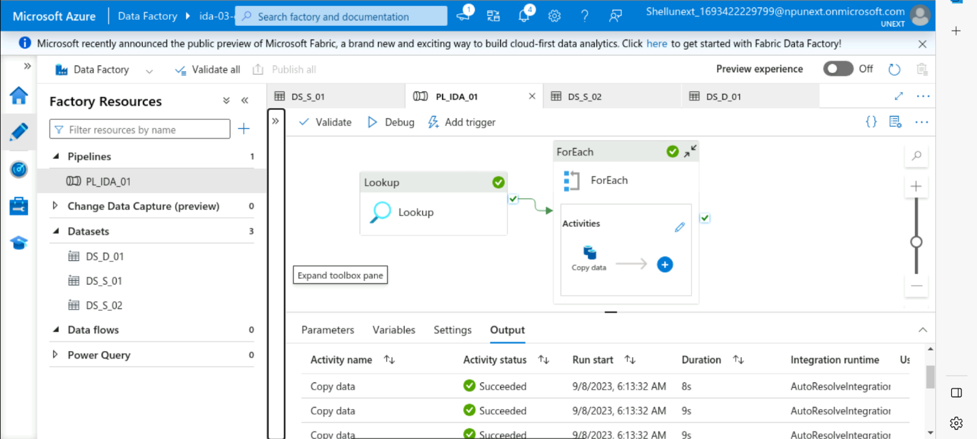

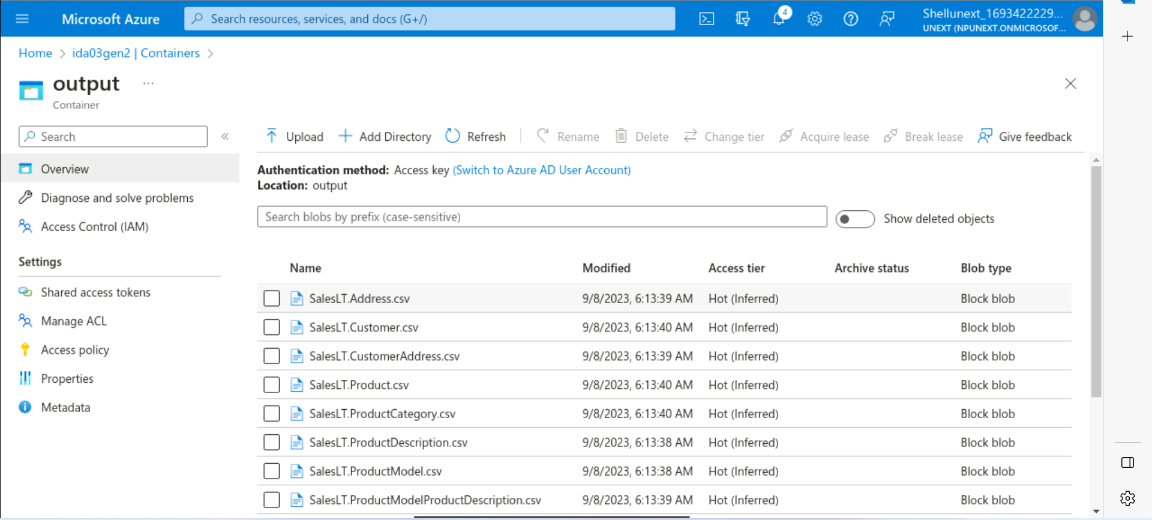

Loads:

Full Load: Whole data will be loaded.

Incremental Load: Only the changes will get loaded.

Schema Drift:

1. Allows schema drift: Keeps track of changes in the number of columns
2. Infer drifted column types: Keeps track of changes in the data type of the columns

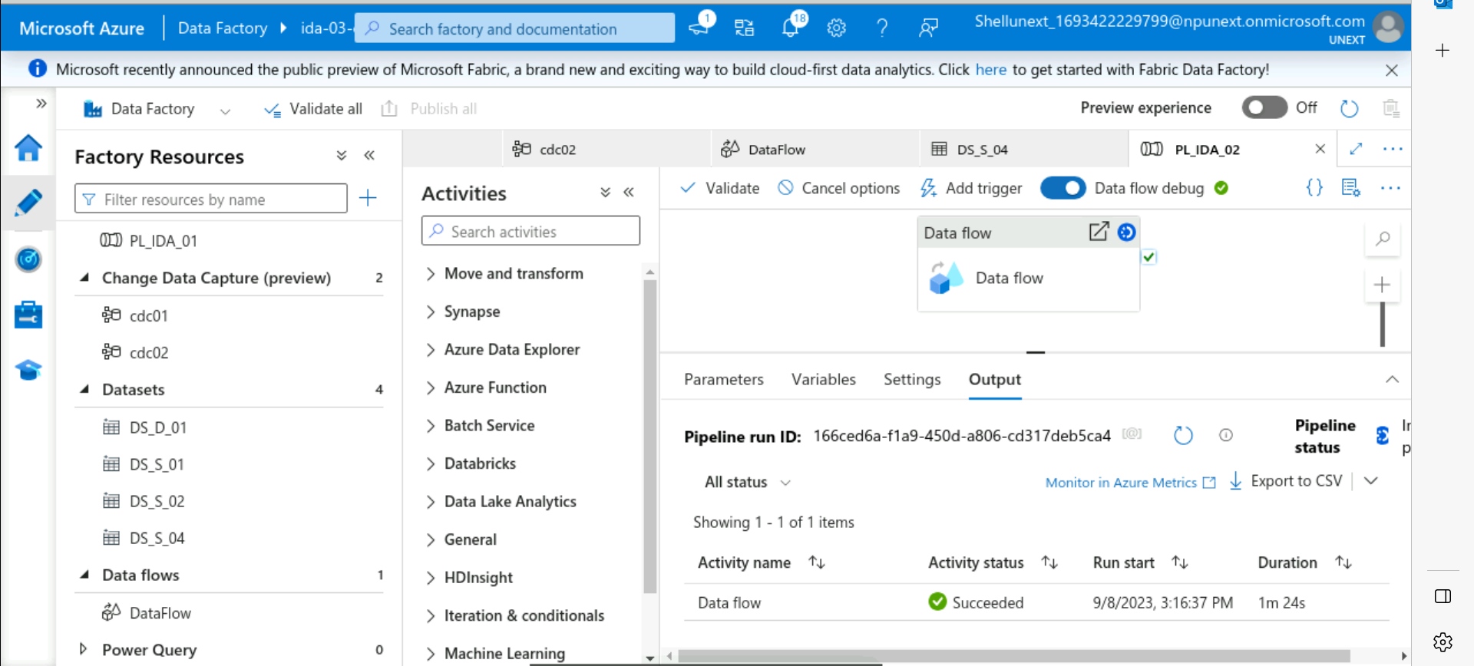

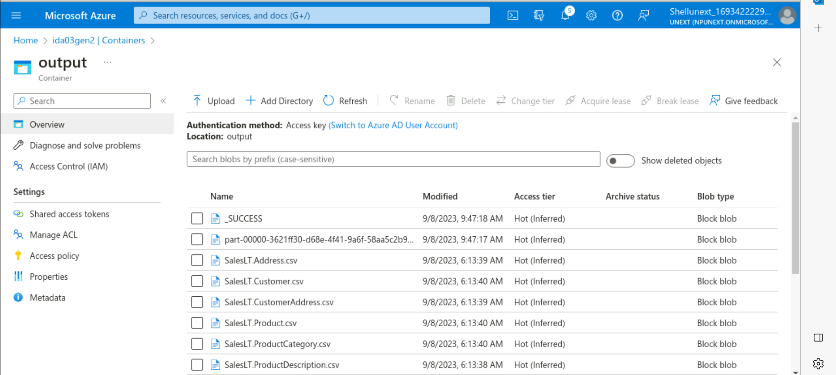

Azure run book:

1. Set of instructions to carry out some executions
2. Example: Azure Automation Run Book

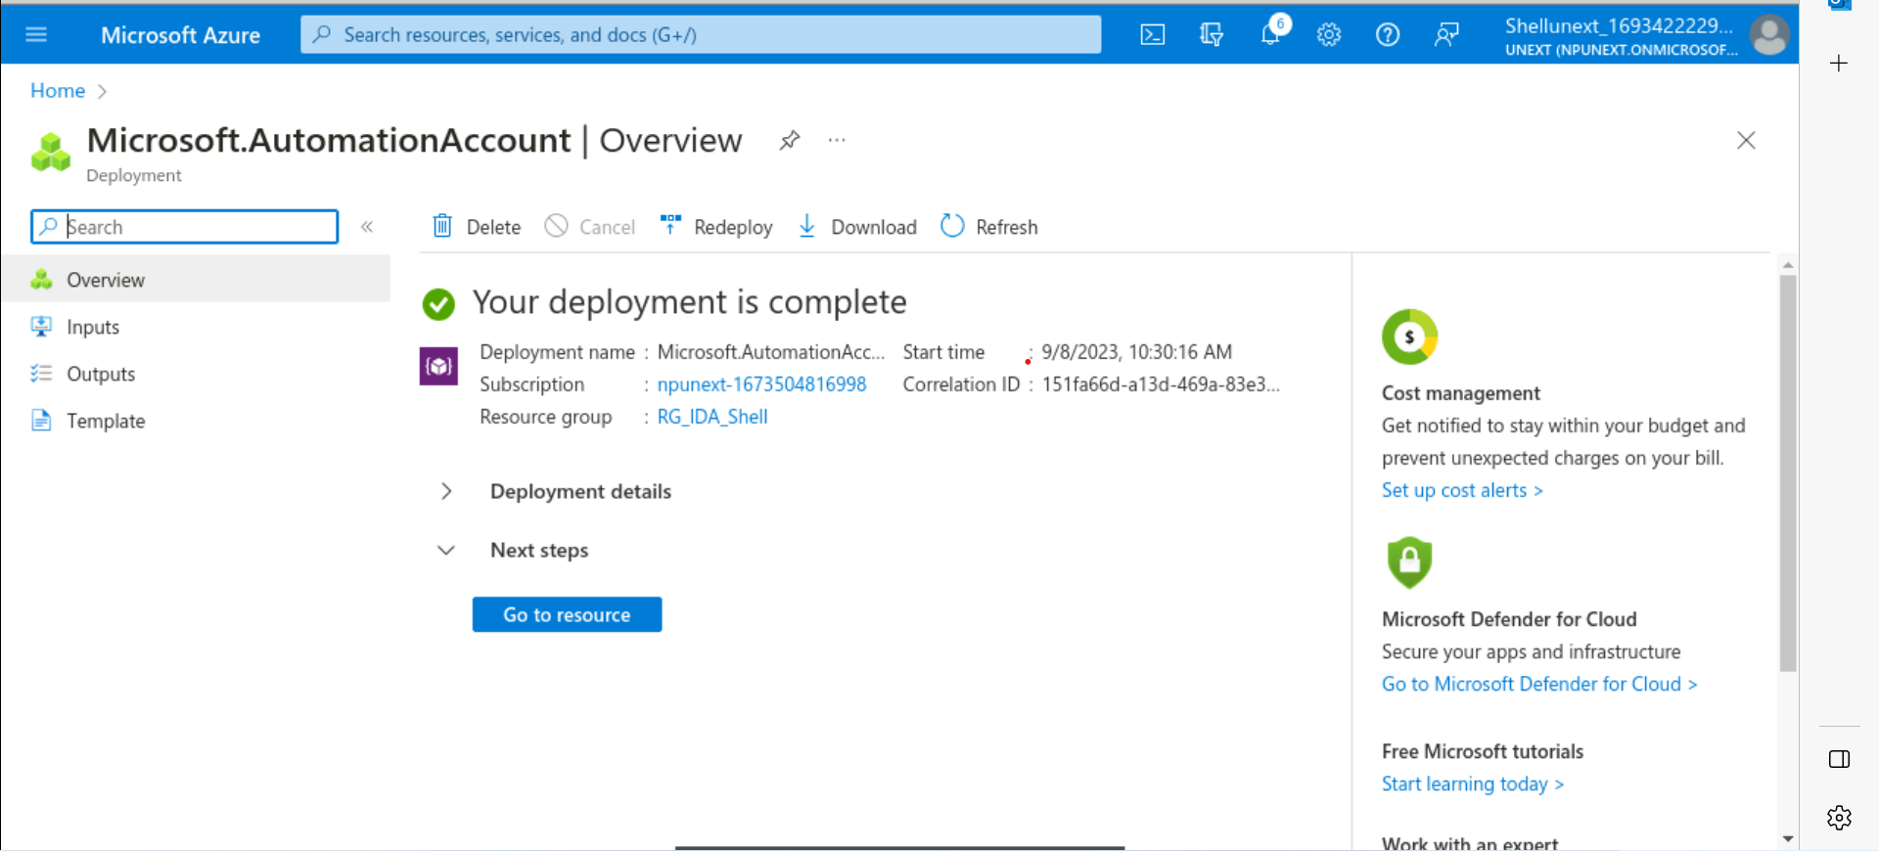

Pipeline: Always gives the output

Sequence: Sequentially gives the output

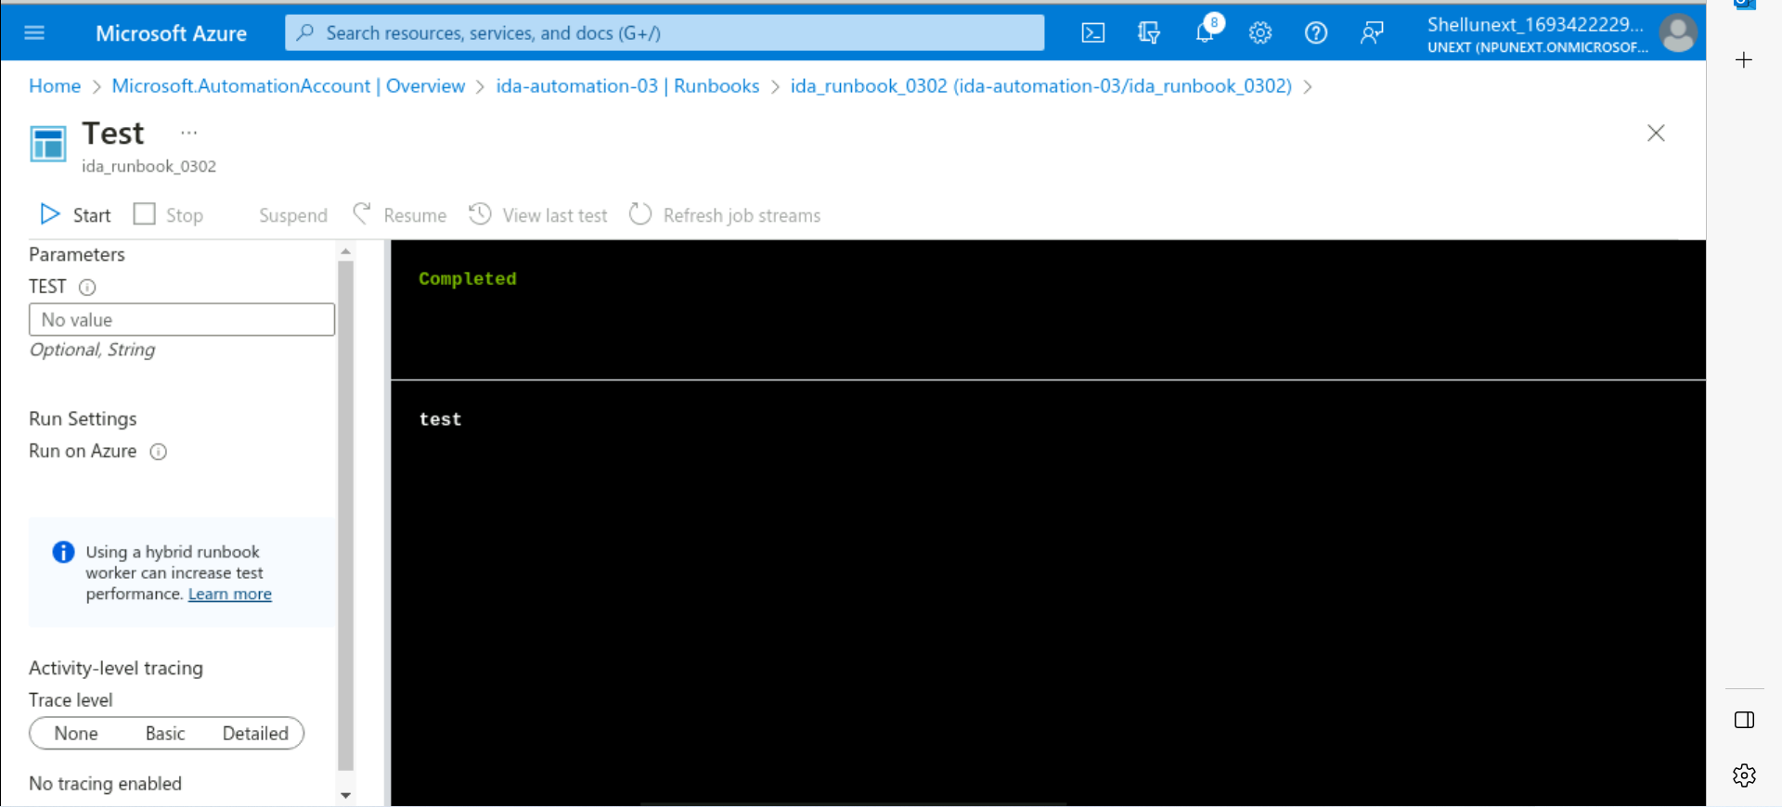

Azure Monitor Service: To monitor all other services and perform some operations based on that.

